Table 1. Demographic variables and background questions.

|  |  |  |
| --- | --- | --- |
| Questions | TIMSS 2015 Variable Name G4 | TIMSS 2019 Variable Name G8 |
| About how many books are there in your home? (Do not count magazines, newspapers, or your school books.) | ASBG04 | BSBG04 |
| Are you a girl or a boy? | ASBG01 | BSBG01 |
| How often do you speak <language of test> at home? | ASBG03 | BSBG03 |
| Do you have any of these things at your home? |  |  |
| A computer or tablet of your own | ASBG05A | BSBG05A |
| Study desk/table for your use | ASBG05C | BSBG05B |
| Your own room | ASBG05D | BSBG05C |
| Internet connection | ASBG05E | BSBG05D |
| During this school year, how often have other students from your school done any of the following things to you? | | |
| Left me out of their games or activities. | ASBG12B | BSBG14M |
| Spread lies about me. | ASBG12C | BSBG14B |
| Stole something from me. | ASBG12D | BSBG14F |
| Hit or hurt me. | ASBG12E | BSBG14L |
| Shared embarrassing information about me. | ASBG12G | BSBG14J |
| Threatened me. | ASBG12H | BSBG14K |
| What do you think about your school? Tell how much you agree with these statements. | | |
| I like being in school. | ASBG11A | BSBG13A |
| I feel safe when I am at school. | ASBG11B | BSBG13B |
| I feel like I belong at this school. | ASBG11C | BSBG13C |
| Teachers at my school are fair to me | ASBG11E | BSBG13D |
| I am proud to go to this school. | ASBG11F | BSBG13E |
| How much do you agree with these statements about learning mathematics? | | |
| I enjoy learning mathematics. | ASBM01A | BSBM16A |
| I wish I did not have to study mathematics. | ASBM01B | BSBM16B |
| Mathematics is boring. | ASBM01C | BSBM16C |
| I learn many interesting things in mathematics. | ASBM01D | BSBM16D |
| I like mathematics. | ASBM01E | BSBM16E |
| I like any schoolwork that involves numbers. | ASBM01F | BSBM16F |
| I like to solve mathematics problems. | ASBM01G | BSBM16G |
| I look forward to mathematics class. | ASBM01H | BSBM16H |
| Mathematics is one of my favorite subjects. | ASBM01I | BSBM16I |
| How much do you agree with these statements about your mathematics lessons? | | |
| I know what my teacher expects me to do. | ASBM02A | BSBM17A |
| My teacher is easy to understand. | ASBM02B | BSBM17B |
| My teacher has clear answers to my questions. | ASBM02E | BSBM17C |
| My teacher is good at explaining mathematics. | ASBM02F | BSBM17D |
| My teacher does a variety of things to help us learn. | ASBM02H | BSBM17E |
| How much do you agree with these statements about mathematics? | | |
| I usually do well in mathematics. | ASBM03A | BSBM19A |
| Mathematics is more difficult for me than for many of my classmates. | ASBM03B | BSBM19B |
| Mathematics is not one of my strengths. | ASBM03C | BSBM19C |
| I learn things quickly in mathematics. | ASBM03D | BSBM19D |
| Mathematics makes me nervous. | ASBM03E | BSBM19E |
| I am good at working out difficult mathematics problems. | ASBM03F | BSBM19F |
| My teacher tells me I am good at mathematics. | ASBM03G | BSBM19G |
| Mathematics is harder for me than any other subject. | ASBM03H | BSBM19H |
| Mathematics makes me confused. | ASBM03I | BSBM19I |

We used the data from 29 countries/jurisdictions. These 29 countries/jurisdictions are:

Abu Dhabi, Australia, Bahrain, Chile, Dubai, England, Georgia, Hong Kong, Hungary, Iran, Ireland, Italy, Japan, Kazakhstan, Korea, Kuwait, Lithuania, Morocco, New Zealand, Oman, Ontario, Quebec, Russia, Singapore, Sweden, Taipei, Turkey, UAE, and the US.

The “best” NN model:

80% training, 20% validation

Four layers:

1st layer: 32 neurons, relu

2nd layer: 64 neurons, relu

3rd layer: 16 neurons, relu

4th layer: 1 neuron, relu.

Loss function = mean squared error

Optimizer: stochastic gradient descent, learning rate = 0.05, momentum = 0.003.

Epochs = 350, batch size = 128.

Table 2. By using our “best” NN model, the prediction results for each country’s Grade 8 math score are shown in the following table. (The predictions were done by changing the grade indicator from 0 to 1.)

|  |  |  |  |  |  |  |
| --- | --- | --- | --- | --- | --- | --- |
| Country | Predicted mean | Actual mean | Bias for mean | Predicted SD | Actual SD | Bias for SD |
| Abu Dhabi | 429.5 | 436.5 | 6.9 | 65.2 | 98.2 | 33.0 |
| Australia | 523.0 | 530.4 | 7.4 | 68.3 | 87.2 | 18.9 |
| Bahrain | 470.6 | 481.4 | 10.8 | 46.9 | 90.1 | 43.2 |
| Chile | 443.8 | 448.5 | 4.6 | 55.6 | 74.9 | 19.3 |
| Dubai | 514.3 | 527.5 | 13.2 | 62.1 | 89.5 | 27.5 |
| England | 529.9 | 517.3 | -12.6 | 61.5 | 83.5 | 22.0 |
| Georgia | 469.5 | 462.3 | -7.2 | 56.5 | 84.6 | 28.1 |
| Hong Kong | 586.2 | 578.2 | -8.0 | 55.4 | 85.4 | 30.0 |
| Hungary | 531.6 | 529.4 | -2.2 | 70.8 | 85.6 | 14.7 |
| Iran | 423.4 | 448.1 | 24.7 | 58.9 | 87.8 | 28.9 |
| Ireland | 529.7 | 527.0 | -2.8 | 56.4 | 68.6 | 12.3 |
| Italy | 485.9 | 499.6 | 13.7 | 49.3 | 68.3 | 18.9 |
| Japan | 604.8 | 593.9 | -11.0 | 58.7 | 81.2 | 22.5 |
| Kazakhstan | 496.4 | 489.2 | -7.2 | 42.0 | 79.5 | 37.5 |
| Korea | 616.3 | 605.6 | -10.7 | 59.2 | 93.8 | 34.6 |
| Kuwait | 399.4 | 400.8 | 1.4 | 50.4 | 81.2 | 30.8 |
| Lithuania | 506.2 | 517.4 | 11.2 | 63.5 | 81.8 | 18.3 |
| Morocco | 379.6 | 385.3 | 5.8 | 42.7 | 62.4 | 19.7 |
| New Zealand | 498.1 | 500.7 | 2.6 | 70.2 | 92.3 | 22.2 |
| Oman | 412.8 | 413.3 | 0.6 | 58.1 | 96.0 | 37.9 |
| Ontario | 515.4 | 527.9 | 12.5 | 56.2 | 74.8 | 18.6 |
| Quebec | 544.3 | 545.6 | 1.3 | 50.8 | 64.0 | 13.2 |
| Russia | 549.0 | 545.2 | -3.8 | 55.2 | 78.8 | 23.6 |
| Singapore | 598.1 | 610.3 | 12.2 | 66.3 | 87.3 | 21.0 |
| Sweden | 527.3 | 506.2 | -21.1 | 51.5 | 74.1 | 22.6 |
| Taipei | 613.6 | 610.7 | -2.9 | 63.3 | 95.8 | 32.5 |
| Turkey | 487.4 | 491.0 | 3.6 | 79.8 | 105.1 | 25.3 |
| UAE | 457.9 | 467.0 | 9.1 | 62.9 | 97.1 | 34.2 |
| US | 518.5 | 517.0 | -1.4 | 68.0 | 95.5 | 27.5 |

We will use the distribution shifts of the background variables to adjust the bias for mean and SD.

Table 3. Mean differences between G4 and G8 (G8 mean – G4 mean) and the correlation between the mean differences and the 1st round prediction bias.

|  |  |  |  |  |  |  |
| --- | --- | --- | --- | --- | --- | --- |
| Country | BSBG05A  ASBG05A | BSBG05B  ASBG05C | BSBG05C  ASBG05D | BSBG05D  ASBG05E | Bias for mean | Bias for SD |
| Abu Dhabi | 0.134 | 0.130 | 0.113 | 0.108 | 6.937 | 32.998 |
| Australia | 0.283 | 0.182 | 0.140 | 0.133 | 7.442 | 18.914 |
| Bahrain | 0.137 | 0.106 | 0.138 | 0.128 | 10.769 | 43.196 |
| Chile | 0.165 | 0.051 | 0.055 | 0.106 | 4.635 | 19.266 |
| Dubai | 0.170 | 0.094 | 0.115 | 0.060 | 13.218 | 27.473 |
| England | 0.189 | 0.158 | 0.146 | 0.045 | -12.603 | 22.017 |
| Georgia | 0.139 | 0.088 | 0.177 | 0.173 | -7.216 | 28.073 |
| Hong Kong | 0.448 | 0.164 | 0.088 | 0.238 | -7.975 | 29.992 |
| Hungary | 0.398 | 0.092 | 0.216 | 0.103 | -2.199 | 14.749 |
| Iran | 0.183 | 0.063 | 0.053 | 0.303 | 24.737 | 28.944 |
| Ireland | 0.172 | 0.249 | 0.107 | 0.066 | -2.758 | 12.274 |
| Italy | 0.445 | 0.296 | 0.142 | 0.220 | 13.726 | 18.943 |
| Japan | 0.536 | 0.082 | 0.140 | 0.284 | -10.968 | 22.536 |
| Kazakhstan | 0.194 | 0.048 | 0.101 | 0.282 | -7.166 | 37.520 |
| Korea | 0.743 | 0.086 | 0.233 | 0.072 | -10.718 | 34.593 |
| Kuwait | -0.013 | 0.041 | 0.177 | 0.138 | 1.370 | 30.765 |
| Lithuania | 0.289 | 0.114 | 0.205 | 0.151 | 11.164 | 18.278 |
| Morocco | 0.290 | 0.119 | 0.159 | 0.192 | 5.793 | 19.689 |
| New Zealand | 0.268 | 0.146 | 0.133 | 0.087 | 2.567 | 22.196 |
| Oman | 0.149 | 0.081 | 0.177 | 0.214 | 0.560 | 37.918 |
| Ontario | 0.272 | 0.220 | 0.152 | 0.063 | 12.519 | 18.572 |
| Quebec | 0.279 | 0.141 | 0.124 | 0.056 | 1.302 | 13.178 |
| Russia | 0.178 | 0.127 | 0.204 | 0.089 | -3.803 | 23.627 |
| Singapore | 0.398 | 0.086 | 0.124 | 0.064 | 12.207 | 20.976 |
| Sweden | 0.221 | 0.040 | 0.090 | 0.047 | -21.060 | 22.582 |
| Taipei | 0.430 | 0.110 | 0.196 | 0.097 | -2.860 | 32.519 |
| Turkey | 0.164 | 0.082 | 0.110 | 0.133 | 3.625 | 25.298 |
| UAE | 0.138 | 0.103 | 0.126 | 0.102 | 9.054 | 34.231 |
| US | 0.168 | 0.156 | 0.150 | 0.076 | -1.441 | 27.531 |
|  | -0.219 | 0.194 | -0.211 | 0.136 |  |  |
|  | -0.149 | -0.428* | 0.039 | 0.289 |  |  |

*Note:* * Correlation is significant at the 0.05 level (2-tailed).

Table 4. Mean differences between G4 and G8 (G8 mean – G4 mean) and the correlation between the mean differences and the 1st round prediction bias.

|  |  |  |  |  |  |  |  |  |
| --- | --- | --- | --- | --- | --- | --- | --- | --- |
| Country | BSBG14M  ASBG12B | BSBG14B  ASBG12C | BSBG14F  ASBG12D | BSBG14L  ASBG12E | BSBG14J  ASBG12G | BSBG14K  ASBG12H | Bias for mean | Bias for SD |
| Abu Dhabi | -0.475 | -0.006 | -0.171 | -0.380 | -0.396 | -0.290 | 6.937 | 32.998 |
| Australia | -0.394 | -0.118 | -0.073 | -0.520 | -0.291 | -0.257 | 7.442 | 18.914 |
| Bahrain | -0.759 | -0.193 | -0.344 | -0.678 | -0.581 | -0.562 | 10.769 | 43.196 |
| Chile | -0.297 | 0.178 | 0.035 | -0.474 | -0.189 | -0.233 | 4.635 | 19.266 |
| Dubai | -0.456 | -0.165 | -0.309 | -0.559 | -0.443 | -0.373 | 13.218 | 27.473 |
| England | -0.486 | 0.004 | -0.015 | -0.545 | -0.161 | -0.202 | -12.603 | 22.017 |
| Georgia | -0.575 | 0.042 | -0.078 | -0.385 | -0.155 | -0.139 | -7.216 | 28.073 |
| Hong Kong | -0.414 | 0.060 | -0.020 | -0.220 | -0.063 | -0.207 | -7.975 | 29.992 |
| Hungary | -0.494 | -0.116 | -0.126 | -0.609 | -0.163 | -0.193 | -2.199 | 14.749 |
| Iran | -0.825 | -0.111 | -0.395 | -0.666 | -0.444 | -0.328 | 24.737 | 28.944 |
| Ireland | -0.045 | 0.127 | 0.104 | -0.262 | -0.020 | -0.029 | -2.758 | 12.274 |
| Italy | -0.329 | -0.285 | -0.199 | -0.444 | -0.471 | -0.315 | 13.726 | 18.943 |
| Japan | -0.400 | 0.022 | -0.183 | -0.549 | -0.320 | -0.222 | -10.968 | 22.536 |
| Kazakhstan | -0.431 | 0.109 | -0.142 | -0.232 | -0.093 | -0.138 | -7.166 | 37.520 |
| Korea | -0.357 | -0.018 | 0.015 | -0.324 | -0.154 | -0.068 | -10.718 | 34.593 |
| Kuwait | -0.480 | 0.002 | -0.254 | -0.482 | -0.372 | -0.389 | 1.370 | 30.765 |
| Lithuania | -0.664 | -0.316 | -0.141 | -0.616 | -0.310 | -0.174 | 11.164 | 18.278 |
| Morocco | -0.567 | 0.003 | 0.144 | -0.522 | -0.396 | -0.320 | 5.793 | 19.689 |
| New Zealand | -0.608 | -0.200 | -0.221 | -0.608 | -0.317 | -0.321 | 2.567 | 22.196 |
| Oman | -0.449 | 0.045 | -0.130 | -0.527 | -0.528 | -0.328 | 0.560 | 37.918 |
| Ontario | -0.383 | -0.005 | -0.114 | -0.494 | -0.187 | -0.248 | 12.519 | 18.572 |
| Quebec | -0.588 | -0.087 | -0.186 | -0.487 | -0.438 | -0.272 | 1.302 | 13.178 |
| Russia | -0.884 | -0.158 | -0.129 | -0.658 | -0.312 | -0.204 | -3.803 | 23.627 |
| Singapore | -0.303 | -0.132 | -0.217 | -0.496 | -0.255 | -0.349 | 12.207 | 20.976 |
| Sweden | -0.276 | 0.036 | 0.004 | -0.363 | -0.177 | -0.051 | -21.060 | 22.582 |
| Taipei | -0.544 | -0.269 | -0.300 | -0.483 | -0.516 | -0.321 | -2.860 | 32.519 |
| Turkey | -0.483 | 0.087 | -0.053 | -0.334 | -0.416 | -0.091 | 3.625 | 25.298 |
| UAE | -0.513 | -0.045 | -0.245 | -0.425 | -0.415 | -0.329 | 9.054 | 34.231 |
| US | -0.282 | -0.034 | -0.124 | -0.410 | -0.220 | -0.212 | -1.441 | 27.531 |
|  | -0.295 | -0.438* | -0.513** | -0.444* | -0.531** | -0.606** |  |  |
|  | -0.274 | 0.049 | -0.402* | 0.111 | -0.335 | -0.357 |  |  |

*Note:* ** Correlation is significant at the 0.01 level (2-tailed).  
 * Correlation is significant at the 0.05 level (2-tailed).

Table 5. Mean differences between G4 and G8 (G8 mean – G4 mean) and the correlation between the mean differences and the 1st round prediction bias.

|  |  |  |  |  |  |  |  |
| --- | --- | --- | --- | --- | --- | --- | --- |
| Country | BSBG13A  ASBG11A | BSBG13B  ASBG11B | BSBG13C  ASBG11C | BSBG13D  ASBG11E | BSBG13E  ASBG11F | Bias for mean | Bias for SD |
| Abu Dhabi | -0.437 | -0.122 | -0.286 | -0.361 | -0.321 | 6.937 | 32.998 |
| Australia | -0.300 | -0.188 | -0.259 | -0.408 | -0.429 | 7.442 | 18.914 |
| Bahrain | -0.419 | -0.157 | -0.239 | -0.250 | -0.210 | 10.769 | 43.196 |
| Chile | -0.356 | -0.356 | -0.361 | -0.342 | -0.446 | 4.635 | 19.266 |
| Dubai | -0.329 | -0.020 | -0.136 | -0.273 | -0.274 | 13.218 | 27.473 |
| England | -0.575 | -0.402 | -0.368 | -0.638 | -0.580 | -12.603 | 22.017 |
| Georgia | -0.446 | 0.116 | 0.014 | -0.094 | -0.118 | -7.216 | 28.073 |
| Hong Kong | -0.209 | -0.347 | -0.272 | -0.350 | -0.197 | -7.975 | 29.992 |
| Hungary | -0.404 | -0.184 | -0.424 | -0.474 | -0.518 | -2.199 | 14.749 |
| Iran | -0.346 | -0.065 | -0.232 | -0.408 | -0.142 | 24.737 | 28.944 |
| Ireland | -0.356 | -0.316 | -0.351 | -0.564 | -0.463 | -2.758 | 12.274 |
| Italy | -0.357 | -0.229 | -0.264 | -0.244 | -0.325 | 13.726 | 18.943 |
| Japan | -0.260 | -0.296 | -0.022 | -0.189 | -0.307 | -10.968 | 22.536 |
| Kazakhstan | -0.433 | -0.219 | -0.269 | -0.290 | -0.236 | -7.166 | 37.520 |
| Korea | -0.392 | -0.377 | -0.228 | -0.357 | -0.551 | -10.718 | 34.593 |
| Kuwait | -0.385 | -0.258 | -0.351 | -0.368 | -0.273 | 1.370 | 30.765 |
| Lithuania | -0.441 | -0.039 | -0.247 | -0.422 | -0.386 | 11.164 | 18.278 |
| Morocco | -0.280 | -0.219 | -0.190 | -0.303 | -0.199 | 5.793 | 19.689 |
| New Zealand | -0.387 | -0.198 | -0.287 | -0.328 | -0.367 | 2.567 | 22.196 |
| Oman | -0.446 | -0.220 | -0.306 | -0.402 | -0.260 | 0.560 | 37.918 |
| Ontario | -0.354 | -0.127 | -0.212 | -0.296 | -0.491 | 12.519 | 18.572 |
| Quebec | -0.375 | -0.168 | -0.342 | -0.286 | -0.580 | 1.302 | 13.178 |
| Russia | -0.546 | -0.390 | -0.266 | -0.448 | -0.496 | -3.803 | 23.627 |
| Singapore | -0.357 | -0.118 | -0.272 | -0.220 | -0.359 | 12.207 | 20.976 |
| Sweden | -0.468 | -0.209 | -0.349 | -0.501 | -0.618 | -21.060 | 22.582 |
| Taipei | -0.334 | -0.179 | -0.190 | -0.206 | -0.074 | -2.860 | 32.519 |
| Turkey | -0.433 | -0.267 | -0.226 | -0.011 | -0.308 | 3.625 | 25.298 |
| UAE | -0.399 | -0.092 | -0.210 | -0.282 | -0.273 | 9.054 | 34.231 |
| US | -0.445 | -0.335 | -0.362 | -0.362 | -0.523 | -1.441 | 27.531 |
|  | 0.254 | 0.480** | 0.078 | 0.226 | 0.336 |  |  |
|  | -0.138 | 0.084 | 0.231 | 0.249 | 0.530** |  |  |

*Note:* ** Correlation is significant at the 0.01 level (2-tailed).

Table 6. Mean differences between G4 and G8 (G8 mean – G4 mean) and the correlation between the mean differences and the 1st round prediction bias.

|  |  |  |  |  |  |  |  |  |  |  |  |
| --- | --- | --- | --- | --- | --- | --- | --- | --- | --- | --- | --- |
| Country | BSBM16A  ASBM01A | BSBM16B  ASBM01B | BSBM16C  ASBM01C | BSBM16D  ASBM01D | BSBM16E  ASBM01E | BSBM16F  ASBM01F | BSBM16G  ASBM01G | BSBM16H  ASBM01H | BSBM16I  ASBM01I | Bias for mean | Bias for SD |
| Abu Dhabi | -0.463 | 0.383 | 0.633 | -0.430 | -0.496 | -0.598 | -0.530 | -0.500 | -0.539 | 6.937 | 32.998 |
| Australia | -0.398 | 0.264 | 0.622 | -0.549 | -0.420 | -0.555 | -0.466 | -0.553 | -0.519 | 7.442 | 18.914 |
| Bahrain | -0.622 | 0.395 | 0.536 | -0.607 | -0.693 | -0.711 | -0.645 | -0.772 | -0.680 | 10.769 | 43.196 |
| Chile | -0.505 | 0.367 | 0.461 | -0.578 | -0.570 | -0.750 | -0.612 | -0.886 | -0.714 | 4.635 | 19.266 |
| Dubai | -0.432 | 0.457 | 0.572 | -0.460 | -0.487 | -0.532 | -0.509 | -0.528 | -0.535 | 13.218 | 27.473 |
| England | -0.637 | 0.572 | 0.919 | -0.786 | -0.707 | -0.739 | -0.693 | -0.870 | -0.952 | -12.603 | 22.017 |
| Georgia | -0.515 | 0.396 | 0.559 | -0.261 | -0.571 | -0.626 | -0.655 | -0.905 | -0.827 | -7.216 | 28.073 |
| Hong Kong | -0.469 | 0.645 | 0.616 | -0.571 | -0.509 | -0.504 | -0.348 | -0.451 | -0.470 | -7.975 | 29.992 |
| Hungary | -0.668 | 0.417 | 0.645 | -0.811 | -0.706 | -0.734 | -0.624 | -0.805 | -0.821 | -2.199 | 14.749 |
| Iran | -0.420 | 0.430 | 0.451 | -0.388 | -0.527 | -0.408 | -0.488 | -0.766 | -0.658 | 24.737 | 28.944 |
| Ireland | -0.472 | 0.373 | 0.626 | -0.735 | -0.499 | -0.569 | -0.547 | -0.566 | -0.640 | -2.758 | 12.274 |
| Italy | -0.636 | 0.567 | 0.766 | -0.707 | -0.690 | -0.883 | -0.678 | -0.883 | -0.750 | 13.726 | 18.943 |
| Japan | -0.382 | 0.581 | 0.471 | -0.582 | -0.492 | -0.599 | -0.464 | -0.439 | -0.362 | -10.968 | 22.536 |
| Kazakhstan | -0.592 | 0.275 | 0.317 | -0.469 | -0.613 | -0.752 | -0.655 | -0.919 | -0.858 | -7.166 | 37.520 |
| Korea | -0.448 | 0.746 | 0.555 | -0.472 | -0.469 | -0.498 | -0.424 | -0.392 | -0.286 | -10.718 | 34.593 |
| Kuwait | -0.616 | 0.516 | 0.635 | -0.647 | -0.787 | -0.712 | -0.717 | -0.861 | -0.794 | 1.370 | 30.765 |
| Lithuania | -0.561 | 0.449 | 0.713 | -0.737 | -0.654 | -0.793 | -0.637 | -1.053 | -0.823 | 11.164 | 18.278 |
| Morocco | -0.441 | 0.063 | 0.201 | -0.298 | -0.473 | -0.465 | -0.642 | -0.544 | -0.501 | 5.793 | 19.689 |
| New Zealand | -0.445 | 0.433 | 0.636 | -0.528 | -0.510 | -0.572 | -0.518 | -0.617 | -0.629 | 2.567 | 22.196 |
| Oman | -0.522 | 0.481 | 0.421 | -0.480 | -0.631 | -0.570 | -0.566 | -0.701 | -0.690 | 0.560 | 37.918 |
| Ontario | -0.145 | 0.028 | 0.424 | -0.380 | -0.174 | -0.284 | -0.194 | -0.336 | -0.182 | 12.519 | 18.572 |
| Quebec | -0.577 | 0.467 | 0.673 | -0.704 | -0.636 | -0.644 | -0.497 | -0.852 | -0.714 | 1.302 | 13.178 |
| Russia | -0.485 | 0.382 | 0.468 | -0.665 | -0.549 | -0.725 | -0.560 | -0.762 | -0.723 | -3.803 | 23.627 |
| Singapore | -0.189 | 0.372 | 0.406 | -0.335 | -0.234 | -0.341 | -0.079 | -0.351 | -0.240 | 12.207 | 20.976 |
| Sweden | -0.553 | 0.632 | 0.624 | -0.667 | -0.580 | -0.630 | -0.499 | -0.619 | -0.580 | -21.060 | 22.582 |
| Taipei | -0.263 | 0.400 | 0.322 | -0.463 | -0.297 | -0.436 | -0.245 | -0.204 | -0.217 | -2.860 | 32.519 |
| Turkey | -0.543 | 1.074 | 0.821 | -0.538 | -0.659 | -0.815 | -0.753 | -0.997 | -0.919 | 3.625 | 25.298 |
| UAE | -0.476 | 0.420 | 0.604 | -0.459 | -0.529 | -0.565 | -0.546 | -0.566 | -0.559 | 9.054 | 34.231 |
| US | -0.458 | 0.356 | 0.625 | -0.597 | -0.499 | -0.587 | -0.564 | -0.495 | -0.505 | -1.441 | 27.531 |
|  | 0.247 | -0.317 | -0.113 | 0.290 | 0.176 | 0.195 | 0.100 | -0.058 | 0.073 |  |  |
|  | -0.072 | 0.145 | -0.249 | 0.380* | -0.103 | 0.052 | -0.065 | 0.103 | 0.058 |  |  |

*Note:* * Correlation is significant at the 0.05 level (2-tailed).

Table 7. Mean differences between G4 and G8 (G8 mean – G4 mean) and the correlation between the mean differences and the 1st round prediction bias.

|  |  |  |  |  |  |  |  |
| --- | --- | --- | --- | --- | --- | --- | --- |
| Country | BSBM17A ASBM02A | BSBM17B ASBM02B | BSBM17C  ASBM02E | BSBM17D ASBM02F | BSBM17E ASBM02H | Bias for mean | Bias for SD |
| Abu Dhabi | -0.007 | -0.248 | -0.243 | -0.254 | -0.236 | 6.937 | 32.998 |
| Australia | -0.097 | -0.335 | -0.336 | -0.360 | -0.491 | 7.442 | 18.914 |
| Bahrain | -0.157 | -0.305 | -0.322 | -0.272 | -0.299 | 10.769 | 43.196 |
| Chile | -0.391 | -0.490 | -0.470 | -0.518 | -0.558 | 4.635 | 19.266 |
| Dubai | -0.100 | -0.181 | -0.168 | -0.145 | -0.219 | 13.218 | 27.473 |
| England | -0.238 | -0.461 | -0.462 | -0.493 | -0.631 | -12.603 | 22.017 |
| Georgia | 0.146 | -0.171 | 0.004 | -0.016 | -0.080 | -7.216 | 28.073 |
| Hong Kong | -0.299 | -0.446 | -0.410 | -0.527 | -0.520 | -7.975 | 29.992 |
| Hungary | -0.349 | -0.542 | -0.545 | -0.619 | -0.713 | -2.199 | 14.749 |
| Iran | -0.125 | -0.349 | -0.313 | -0.359 | -0.361 | 24.737 | 28.944 |
| Ireland | -0.213 | -0.535 | -0.454 | -0.512 | -0.596 | -2.758 | 12.274 |
| Italy | -0.065 | -0.240 | -0.369 | -0.387 | -0.409 | 13.726 | 18.943 |
| Japan | -0.260 | -0.349 | -0.131 | -0.269 | -0.251 | -10.968 | 22.536 |
| Kazakhstan | -0.237 | -0.371 | -0.314 | -0.288 | -0.176 | -7.166 | 37.520 |
| Korea | -0.019 | -0.543 | -0.229 | -0.411 | -0.318 | -10.718 | 34.593 |
| Kuwait | -0.114 | -0.372 | -0.375 | -0.299 | -0.410 | 1.370 | 30.765 |
| Lithuania | -0.282 | -0.352 | -0.408 | -0.395 | -0.427 | 11.164 | 18.278 |
| Morocco | -0.337 | -0.427 | -0.362 | -0.353 | -0.311 | 5.793 | 19.689 |
| New Zealand | -0.154 | -0.374 | -0.387 | -0.419 | -0.449 | 2.567 | 22.196 |
| Oman | -0.270 | -0.387 | -0.311 | -0.285 | -0.313 | 0.560 | 37.918 |
| Ontario | -0.102 | -0.237 | -0.249 | -0.277 | -0.279 | 12.519 | 18.572 |
| Quebec | -0.252 | -0.352 | -0.320 | -0.365 | -0.459 | 1.302 | 13.178 |
| Russia | -0.230 | -0.404 | -0.448 | -0.368 | -0.363 | -3.803 | 23.627 |
| Singapore | -0.135 | -0.214 | -0.193 | -0.257 | -0.311 | 12.207 | 20.976 |
| Sweden | -0.160 | -0.453 | -0.439 | -0.437 | -0.493 | -21.060 | 22.582 |
| Taipei | -0.143 | -0.316 | -0.169 | -0.215 | -0.256 | -2.860 | 32.519 |
| Turkey | -0.112 | -0.110 | -0.212 | -0.213 | -0.329 | 3.625 | 25.298 |
| UAE | -0.082 | -0.243 | -0.223 | -0.200 | -0.219 | 9.054 | 34.231 |
| US | -0.147 | -0.280 | -0.244 | -0.332 | -0.370 | -1.441 | 27.531 |
|  | 0.131 | 0.470* | 0.105 | 0.228 | 0.182 |  |  |
|  | 0.316 | 0.206 | 0.380* | 0.459* | 0.581** |  |  |

*Note:* ** Correlation is significant at the 0.01 level (2-tailed).  
 * Correlation is significant at the 0.05 level (2-tailed).

Table 8. Mean differences between G4 and G8 (G8 mean – G4 mean) and the correlation between the mean differences and the 1st round prediction bias.

|  |  |  |  |  |  |  |  |  |  |  |  |
| --- | --- | --- | --- | --- | --- | --- | --- | --- | --- | --- | --- |
| Country | BSBM19A ASBM03A | BSBM19B ASBM03B | BSBM19C ASBM03C | BSBM19D  ASBM03D | BSBM19E  ASBM03E | BSBM19F  ASBM03F | BSBM19G ASBM03G | BSBM19H  ASBM03H | BSBM19I  ASBM03I | Bias for mean | Bias for SD |
| Abu Dhabi | -0.172 | 0.110 | 0.572 | -0.304 | 0.303 | -0.298 | -0.277 | 0.240 | 0.354 | 6.937 | 32.998 |
| Australia | -0.249 | 0.045 | 0.571 | -0.305 | 0.124 | -0.238 | -0.512 | 0.138 | 0.275 | 7.442 | 18.914 |
| Bahrain | -0.207 | 0.105 | 0.477 | -0.424 | 0.270 | -0.488 | -0.297 | 0.287 | 0.281 | 10.769 | 43.196 |
| Chile | -0.481 | -0.021 | 0.411 | -0.566 | 0.040 | -0.564 | -0.627 | 0.218 | 0.346 | 4.635 | 19.266 |
| Dubai | -0.240 | 0.121 | 0.501 | -0.308 | 0.413 | -0.281 | -0.327 | 0.339 | 0.416 | 13.218 | 27.473 |
| England | -0.384 | 0.176 | 0.751 | -0.446 | 0.173 | -0.282 | -0.737 | 0.294 | 0.514 | -12.603 | 22.017 |
| Georgia | -0.509 | 0.413 | 0.756 | -0.472 | 0.236 | -0.557 | -0.471 | 0.553 | 0.518 | -7.216 | 28.073 |
| Hong Kong | -0.429 | 0.185 | 0.402 | -0.402 | 0.243 | -0.321 | -0.285 | 0.315 | 0.441 | -7.975 | 29.992 |
| Hungary | -0.448 | 0.035 | 0.720 | -0.526 | 0.339 | -0.545 | -0.546 | 0.252 | 0.339 | -2.199 | 14.749 |
| Iran | -0.481 | 0.022 | 0.095 | -0.401 | 0.202 | -0.624 | -0.511 | 0.337 | 0.324 | 24.737 | 28.944 |
| Ireland | -0.425 | 0.257 | 0.787 | -0.494 | 0.332 | -0.424 | -0.577 | 0.336 | 0.610 | -2.758 | 12.274 |
| Italy | -0.537 | 0.310 | 0.723 | -0.547 | 0.430 | -0.535 | -0.534 | 0.524 | 0.508 | 13.726 | 18.943 |
| Japan | -0.463 | 0.274 | 0.575 | -0.352 | 0.422 | -0.451 | -0.366 | 0.347 | 0.515 | -10.968 | 22.536 |
| Kazakhstan | -0.560 | 0.303 | 0.540 | -0.689 | 0.242 | -0.719 | -0.661 | 0.443 | 0.372 | -7.166 | 37.520 |
| Korea | -0.361 | 0.262 | 0.258 | -0.299 | 0.269 | -0.327 | -0.092 | 0.333 | 0.410 | -10.718 | 34.593 |
| Kuwait | -0.232 | 0.464 | 0.769 | -0.451 | 0.552 | -0.561 | -0.378 | 0.636 | 0.580 | 1.370 | 30.765 |
| Lithuania | -0.464 | 0.069 | 0.892 | -0.440 | 0.152 | -0.531 | -0.584 | 0.313 | 0.215 | 11.164 | 18.278 |
| Morocco | -0.288 | 0.133 | 0.386 | -0.380 | 0.003 | -0.565 | -0.528 | 0.201 | 0.117 | 5.793 | 19.689 |
| New Zealand | -0.292 | 0.008 | 0.595 | -0.341 | 0.020 | -0.300 | -0.499 | 0.050 | 0.321 | 2.567 | 22.196 |
| Oman | -0.246 | 0.229 | 0.178 | -0.376 | 0.269 | -0.455 | -0.374 | 0.364 | 0.299 | 0.560 | 37.918 |
| Ontario | -0.048 | -0.076 | 0.364 | -0.086 | 0.097 | -0.070 | -0.297 | -0.023 | 0.084 | 12.519 | 18.572 |
| Quebec | -0.272 | 0.168 | 0.597 | -0.317 | 0.173 | -0.233 | -0.565 | 0.212 | 0.164 | 1.302 | 13.178 |
| Russia | -0.375 | 0.153 | 0.357 | -0.498 | 0.434 | -0.478 | -0.387 | 0.228 | 0.166 | -3.803 | 23.627 |
| Singapore | -0.274 | 0.046 | 0.341 | -0.215 | 0.244 | -0.090 | -0.181 | 0.038 | 0.228 | 12.207 | 20.976 |
| Sweden | -0.529 | 0.315 | 0.854 | -0.460 | 0.236 | -0.414 | -0.632 | 0.357 | 0.579 | -21.060 | 22.582 |
| Taipei | -0.360 | 0.163 | 0.690 | -0.352 | -0.083 | -0.330 | -0.277 | 0.160 | 0.197 | -2.860 | 32.519 |
| Turkey | -0.778 | 0.339 | 0.594 | -0.654 | 0.387 | -0.740 | -0.692 | 0.562 | 0.789 | 3.625 | 25.298 |
| UAE | -0.213 | 0.105 | 0.524 | -0.298 | 0.318 | -0.334 | -0.296 | 0.291 | 0.313 | 9.054 | 34.231 |
| US | -0.238 | 0.126 | 0.576 | -0.302 | 0.166 | -0.327 | -0.482 | 0.248 | 0.372 | -1.441 | 27.531 |
|  | 0.298 | -0.519** | -0.352 | 0.262 | -0.044 | 0.045 | 0.157 | -0.206 | -0.381* |  |  |
|  | 0.148 | 0.239 | -0.346 | -0.017 | 0.129 | -0.174 | 0.453* | 0.282 | 0.043 |  |  |

*Note:* ** Correlation is significant at the 0.01 level (2-tailed).  
 * Correlation is significant at the 0.05 level (2-tailed).

Bias mitigation for the mean.

Table 9. Mean differences between G4 and G8 (G8 mean – G4 mean) for the 8 positive wording questions.

|  |  |  |  |  |  |  |  |  |
| --- | --- | --- | --- | --- | --- | --- | --- | --- |
| Country | BSBG14B  ASBG12C | BSBG14F  ASBG12D | BSBG14L  ASBG12E | BSBG14J  ASBG12G | BSBG14K  ASBG12H | BSBM19B ASBM03B | BSBM19I  ASBM03I | Bias for mean |
| Abu Dhabi | -0.006 | -0.171 | -0.380 | -0.396 | -0.290 | 0.110 | 0.354 | 6.937 |
| Australia | -0.118 | -0.073 | -0.520 | -0.291 | -0.257 | 0.045 | 0.275 | 7.442 |
| Bahrain | -0.193 | -0.344 | -0.678 | -0.581 | -0.562 | 0.105 | 0.281 | 10.769 |
| Chile | 0.178 | 0.035 | -0.474 | -0.189 | -0.233 | -0.021 | 0.346 | 4.635 |
| Dubai | -0.165 | -0.309 | -0.559 | -0.443 | -0.373 | 0.121 | 0.416 | 13.218 |
| England | 0.004 | -0.015 | -0.545 | -0.161 | -0.202 | 0.176 | 0.514 | -12.603 |
| Georgia | 0.042 | -0.078 | -0.385 | -0.155 | -0.139 | 0.413 | 0.518 | -7.216 |
| Hong Kong | 0.060 | -0.020 | -0.220 | -0.063 | -0.207 | 0.185 | 0.441 | -7.975 |
| Hungary | -0.116 | -0.126 | -0.609 | -0.163 | -0.193 | 0.035 | 0.339 | -2.199 |
| Iran | -0.111 | -0.395 | -0.666 | -0.444 | -0.328 | 0.022 | 0.324 | 24.737 |
| Ireland | 0.127 | 0.104 | -0.262 | -0.020 | -0.029 | 0.257 | 0.610 | -2.758 |
| Italy | -0.285 | -0.199 | -0.444 | -0.471 | -0.315 | 0.310 | 0.508 | 13.726 |
| Japan | 0.022 | -0.183 | -0.549 | -0.320 | -0.222 | 0.274 | 0.515 | -10.968 |
| Kazakhstan | 0.109 | -0.142 | -0.232 | -0.093 | -0.138 | 0.303 | 0.372 | -7.166 |
| Korea | -0.018 | 0.015 | -0.324 | -0.154 | -0.068 | 0.262 | 0.410 | -10.718 |
| Kuwait | 0.002 | -0.254 | -0.482 | -0.372 | -0.389 | 0.464 | 0.580 | 1.370 |
| Lithuania | -0.316 | -0.141 | -0.616 | -0.310 | -0.174 | 0.069 | 0.215 | 11.164 |
| Morocco | 0.003 | 0.144 | -0.522 | -0.396 | -0.320 | 0.133 | 0.117 | 5.793 |
| New Zealand | -0.200 | -0.221 | -0.608 | -0.317 | -0.321 | 0.008 | 0.321 | 2.567 |
| Oman | 0.045 | -0.130 | -0.527 | -0.528 | -0.328 | 0.229 | 0.299 | 0.560 |
| Ontario | -0.005 | -0.114 | -0.494 | -0.187 | -0.248 | -0.076 | 0.084 | 12.519 |
| Quebec | -0.087 | -0.186 | -0.487 | -0.438 | -0.272 | 0.168 | 0.164 | 1.302 |
| Russia | -0.158 | -0.129 | -0.658 | -0.312 | -0.204 | 0.153 | 0.166 | -3.803 |
| Singapore | -0.132 | -0.217 | -0.496 | -0.255 | -0.349 | 0.046 | 0.228 | 12.207 |
| Sweden | 0.036 | 0.004 | -0.363 | -0.177 | -0.051 | 0.315 | 0.579 | -21.060 |
| Taipei | -0.269 | -0.300 | -0.483 | -0.516 | -0.321 | 0.163 | 0.197 | -2.860 |
| Turkey | 0.087 | -0.053 | -0.334 | -0.416 | -0.091 | 0.339 | 0.789 | 3.625 |
| UAE | -0.045 | -0.245 | -0.425 | -0.415 | -0.329 | 0.105 | 0.313 | 9.054 |
| US | -0.034 | -0.124 | -0.410 | -0.220 | -0.212 | 0.126 | 0.372 | -1.441 |
|  | -0.438* | -0.513** | -0.444* | -0.531** | -0.606** | -0.519** | -0.381* |  |

Table 10. Mean differences between G4 and G8 (G8 mean – G4 mean) for the 2 negative wording questions.

|  |  |  |  |
| --- | --- | --- | --- |
| Country | BSBG13B  ASBG11B | BSBM17B  ASBM02B | Bias for mean |
| Abu Dhabi | -0.122 | -0.248 | 6.937 |
| Australia | -0.188 | -0.335 | 7.442 |
| Bahrain | -0.157 | -0.305 | 10.769 |
| Chile | -0.356 | -0.490 | 4.635 |
| Dubai | -0.020 | -0.181 | 13.218 |
| England | -0.402 | -0.461 | -12.603 |
| Georgia | 0.116 | -0.171 | -7.216 |
| Hong Kong | -0.347 | -0.446 | -7.975 |
| Hungary | -0.184 | -0.542 | -2.199 |
| Iran | -0.065 | -0.349 | 24.737 |
| Ireland | -0.316 | -0.535 | -2.758 |
| Italy | -0.229 | -0.240 | 13.726 |
| Japan | -0.296 | -0.349 | -10.968 |
| Kazakhstan | -0.219 | -0.371 | -7.166 |
| Korea | -0.377 | -0.543 | -10.718 |
| Kuwait | -0.258 | -0.372 | 1.370 |
| Lithuania | -0.039 | -0.352 | 11.164 |
| Morocco | -0.219 | -0.427 | 5.793 |
| New Zealand | -0.198 | -0.374 | 2.567 |
| Oman | -0.220 | -0.387 | 0.560 |
| Ontario | -0.127 | -0.237 | 12.519 |
| Quebec | -0.168 | -0.352 | 1.302 |
| Russia | -0.390 | -0.404 | -3.803 |
| Singapore | -0.118 | -0.214 | 12.207 |
| Sweden | -0.209 | -0.453 | -21.060 |
| Taipei | -0.179 | -0.316 | -2.860 |
| Turkey | -0.267 | -0.110 | 3.625 |
| UAE | -0.092 | -0.243 | 9.054 |
| US | -0.335 | -0.280 | -1.441 |
|  | 0.480** | 0.470* |  |

Table 11. Below is the correlation matrix for the first principal components for the three matrices together with the bias.

|  |  |  |  |  |
| --- | --- | --- | --- | --- |
| **Correlations** | | | | |
|  | | Bias_For_Mean | REGR factor score 1 for analysis 1 | REGR factor score 1 for analysis 2 |
| Bias_For_Mean | Pearson Correlation | 1 | .534** | -.662** |
| Sig. (2-tailed) |  | .003 | .000 |
| N | 29 | 29 | 29 |
| REGR factor score 1 for analysis 1 | Pearson Correlation | .534** | 1 | -.386* |
| Sig. (2-tailed) | .003 |  | .039 |
| N | 29 | 29 | 29 |
| REGR factor score 1 for analysis 2 | Pearson Correlation | -.662** | -.386* | 1 |
| Sig. (2-tailed) | .000 | .039 |  |
| N | 29 | 29 | 29 |
| **. Correlation is significant at the 0.01 level (2-tailed). | | | | |
| *. Correlation is significant at the 0.05 level (2-tailed). | | | | |

Table 12. Regress the bias on the principal components for matrices 1 and 2.  
Obtain the predicted bias for each country.  
Use the predicted bias to adjust the estimates from the first cycle --> 2nd estimate (i.e. adjusted).  
Compute the new bias for each country --> 2nd bias =  2nd estimate - true value.  
Compare 1st bias and 2nd bias (a table with countries on rows and col. 1 = 1st bias, col. 2 = 2nd bias, col. 3 = col.1 - col.2).

|  |  |  |  |
| --- | --- | --- | --- |
| Country | 1st Bias for mean | Predicted bias (will be used for adjustment) | 1st Bias – predicted bias (the bias after adjustment) |
| Abu Dhabi | 6.94 | 5.14 | 1.80 |
| Australia | 7.44 | 3.91 | 3.53 |
| Bahrain | 10.77 | 13.89 | -3.13 |
| Chile | 4.64 | -5.87 | 10.50 |
| Dubai | 13.22 | 12.61 | 0.61 |
| England | -12.60 | -6.10 | -6.51 |
| Georgia | -7.22 | 2.98 | -10.19 |
| Hong Kong | -7.98 | -8.72 | 0.74 |
| Hungary | -2.20 | 0.05 | -2.25 |
| Iran | 24.74 | 11.08 | 13.66 |
| Ireland | -2.76 | -14.30 | 11.55 |
| Italy | 13.73 | 5.66 | 8.06 |
| Japan | -10.97 | -0.71 | -10.26 |
| Kazakhstan | -7.17 | -5.71 | -1.46 |
| Korea | -10.72 | -10.43 | -0.29 |
| Kuwait | 1.37 | 0.26 | 1.11 |
| Lithuania | 11.16 | 8.46 | 2.70 |
| Morocco | 5.79 | 0.93 | 4.86 |
| New Zealand | 2.57 | 6.63 | -4.07 |
| Oman | 0.56 | 2.95 | -2.39 |
| Ontario | 12.52 | 6.42 | 6.10 |
| Quebec | 1.30 | 5.38 | -4.08 |
| Russia | -3.80 | 1.42 | -5.23 |
| Singapore | 12.21 | 8.89 | 3.32 |
| Sweden | -21.06 | -7.72 | -13.34 |
| Taipei | -2.86 | 9.13 | -11.99 |
| Turkey | 3.63 | -2.53 | 6.15 |
| UAE | 9.05 | 7.79 | 1.27 |
| US | -1.44 | -0.65 | -0.79 |

Bias mitigation for the standard deviation.

Table 13. All the variables whose distribution shifts are significantly correlated with the bias for SD at the .05 level.

|  |  |  |  |  |  |  |  |  |  |  |
| --- | --- | --- | --- | --- | --- | --- | --- | --- | --- | --- |
| Country | BSBG05B  ASBG05C | BSBG14F  ASBG12D | BSBG13E  ASBG11F | BSBM16D  ASBM01D | BSBM17C  ASBM02E | BSBM17D ASBM02F | BSBM17E ASBM02H | BSBM19G ASBM03G | Actual SD | Bias for SD |
| Abu Dhabi | 0.130 | -0.171 | -0.321 | -0.430 | -0.243 | -0.254 | -0.236 | -0.277 | 98.2 | 32.998 |
| Australia | 0.182 | -0.073 | -0.429 | -0.549 | -0.336 | -0.360 | -0.491 | -0.512 | 87.2 | 18.914 |
| Bahrain | 0.106 | -0.344 | -0.210 | -0.607 | -0.322 | -0.272 | -0.299 | -0.297 | 90.1 | 43.196 |
| Chile | 0.051 | 0.035 | -0.446 | -0.578 | -0.470 | -0.518 | -0.558 | -0.627 | 74.9 | 19.266 |
| Dubai | 0.094 | -0.309 | -0.274 | -0.460 | -0.168 | -0.145 | -0.219 | -0.327 | 89.5 | 27.473 |
| England | 0.158 | -0.015 | -0.580 | -0.786 | -0.462 | -0.493 | -0.631 | -0.737 | 83.5 | 22.017 |
| Georgia | 0.088 | -0.078 | -0.118 | -0.261 | 0.004 | -0.016 | -0.080 | -0.471 | 84.6 | 28.073 |
| Hong Kong | 0.164 | -0.020 | -0.197 | -0.571 | -0.410 | -0.527 | -0.520 | -0.285 | 85.4 | 29.992 |
| Hungary | 0.092 | -0.126 | -0.518 | -0.811 | -0.545 | -0.619 | -0.713 | -0.546 | 85.6 | 14.749 |
| Iran | 0.063 | -0.395 | -0.142 | -0.388 | -0.313 | -0.359 | -0.361 | -0.511 | 87.8 | 28.944 |
| Ireland | 0.249 | 0.104 | -0.463 | -0.735 | -0.454 | -0.512 | -0.596 | -0.577 | 68.6 | 12.274 |
| Italy | 0.296 | -0.199 | -0.325 | -0.707 | -0.369 | -0.387 | -0.409 | -0.534 | 68.3 | 18.943 |
| Japan | 0.082 | -0.183 | -0.307 | -0.582 | -0.131 | -0.269 | -0.251 | -0.366 | 81.2 | 22.536 |
| Kazakhstan | 0.048 | -0.142 | -0.236 | -0.469 | -0.314 | -0.288 | -0.176 | -0.661 | 79.5 | 37.520 |
| Korea | 0.086 | 0.015 | -0.551 | -0.472 | -0.229 | -0.411 | -0.318 | -0.092 | 93.8 | 34.593 |
| Kuwait | 0.041 | -0.254 | -0.273 | -0.647 | -0.375 | -0.299 | -0.410 | -0.378 | 81.2 | 30.765 |
| Lithuania | 0.114 | -0.141 | -0.386 | -0.737 | -0.408 | -0.395 | -0.427 | -0.584 | 81.8 | 18.278 |
| Morocco | 0.119 | 0.144 | -0.199 | -0.298 | -0.362 | -0.353 | -0.311 | -0.528 | 62.4 | 19.689 |
| New Zealand | 0.146 | -0.221 | -0.367 | -0.528 | -0.387 | -0.419 | -0.449 | -0.499 | 92.3 | 22.196 |
| Oman | 0.081 | -0.130 | -0.260 | -0.480 | -0.311 | -0.285 | -0.313 | -0.374 | 96.0 | 37.918 |
| Ontario | 0.220 | -0.114 | -0.491 | -0.380 | -0.249 | -0.277 | -0.279 | -0.297 | 74.8 | 18.572 |
| Quebec | 0.141 | -0.186 | -0.580 | -0.704 | -0.320 | -0.365 | -0.459 | -0.565 | 64.0 | 13.178 |
| Russia | 0.127 | -0.129 | -0.496 | -0.665 | -0.448 | -0.368 | -0.363 | -0.387 | 78.8 | 23.627 |
| Singapore | 0.086 | -0.217 | -0.359 | -0.335 | -0.193 | -0.257 | -0.311 | -0.181 | 87.3 | 20.976 |
| Sweden | 0.040 | 0.004 | -0.618 | -0.667 | -0.439 | -0.437 | -0.493 | -0.632 | 74.1 | 22.582 |
| Taipei | 0.110 | -0.300 | -0.074 | -0.463 | -0.169 | -0.215 | -0.256 | -0.277 | 95.8 | 32.519 |
| Turkey | 0.082 | -0.053 | -0.308 | -0.538 | -0.212 | -0.213 | -0.329 | -0.692 | 105.1 | 25.298 |
| UAE | 0.103 | -0.245 | -0.273 | -0.459 | -0.223 | -0.200 | -0.219 | -0.296 | 97.1 | 34.231 |
| US | 0.156 | -0.124 | -0.523 | -0.597 | -0.244 | -0.332 | -0.370 | -0.482 | 95.5 | 27.531 |
|  | -0.428* | -0.402* | 0.530** | 0.380* | 0.380* | 0.459* | 0.581** | 0.453* | 0.605** |  |

Table 14. Below is the correlation matrix for the first principal components for the three matrices together with the bias.

|  |  |  |  |  |  |
| --- | --- | --- | --- | --- | --- |
| **Correlations** | | | | | |
|  | | Bias_for_SD | REGR factor score 1 for analysis 1 | REGR factor score 1 for analysis 2 | Actual_SD |
| Bias_for_SD | Pearson Correlation | 1 | -.541** | .554** | .605** |
| Sig. (2-tailed) |  | .002 | .002 | .001 |
| N | 29 | 29 | 29 | 29 |
| REGR factor score 1 for analysis 1 | Pearson Correlation | -.541** | 1 | -.413* | -.448* |
| Sig. (2-tailed) | .002 |  | .026 | .015 |
| N | 29 | 29 | 29 | 29 |
| REGR factor score 1 for analysis 2 | Pearson Correlation | .554** | -.413* | 1 | .386* |
| Sig. (2-tailed) | .002 | .026 |  | .039 |
| N | 29 | 29 | 29 | 29 |
| Actual_SD | Pearson Correlation | .605** | -.448* | .386* | 1 |
| Sig. (2-tailed) | .001 | .015 | .039 |  |
| N | 29 | 29 | 29 | 29 |
| **. Correlation is significant at the 0.01 level (2-tailed). | | | | | |
| *. Correlation is significant at the 0.05 level (2-tailed). | | | | | |

Table 15. Regress the bias for SD on the principal components for matrices 1 and 2 and actual SD.  
Obtain the predicted bias for each country.  
Use the predicted bias to adjust the estimates from the first cycle --> 2nd estimate (i.e. adjusted).  
Compute the new bias for each country --> 2nd bias =  2nd estimate - true value.  
Compare 1st bias and 2nd bias (a table with countries on rows and col. 1 = 1st bias, col. 2 = 2nd bias, col. 3 = col.1 - col.2).

|  |  |  |  |
| --- | --- | --- | --- |
| Country | 1st Bias for SD | Predicted bias for SD (will be used for adjustment) | 1st Bias – predicted bias for SD (the bias after adjustment) |
| Abu Dhabi | 33.00 | 31.52 | 1.47 |
| Australia | 18.91 | 23.43 | -4.51 |
| Bahrain | 43.20 | 30.44 | 12.76 |
| Chile | 19.27 | 19.78 | -0.52 |
| Dubai | 27.47 | 31.99 | -4.51 |
| England | 22.02 | 18.98 | 3.04 |
| Georgia | 28.07 | 31.19 | -3.12 |
| Hong Kong | 29.99 | 22.66 | 7.33 |
| Hungary | 14.75 | 21.25 | -6.50 |
| Iran | 28.94 | 31.12 | -2.18 |
| Ireland | 12.27 | 12.76 | -0.48 |
| Italy | 18.94 | 16.83 | 2.11 |
| Japan | 22.54 | 27.64 | -5.11 |
| Kazakhstan | 37.52 | 26.86 | 10.66 |
| Korea | 34.59 | 28.10 | 6.49 |
| Kuwait | 30.77 | 27.20 | 3.57 |
| Lithuania | 18.28 | 23.10 | -4.82 |
| Morocco | 19.69 | 17.86 | 1.83 |
| New Zealand | 22.20 | 26.97 | -4.77 |
| Oman | 37.92 | 30.59 | 7.32 |
| Ontario | 18.57 | 22.04 | -3.47 |
| Quebec | 13.18 | 18.08 | -4.90 |
| Russia | 23.63 | 22.43 | 1.20 |
| Singapore | 20.98 | 30.21 | -9.23 |
| Sweden | 22.58 | 20.04 | 2.55 |
| Taipei | 32.52 | 33.50 | -0.98 |
| Turkey | 25.30 | 32.04 | -6.74 |
| UAE | 34.23 | 32.87 | 1.36 |
| US | 27.53 | 27.38 | 0.15 |

Stem-leaf-plot for mean bias.

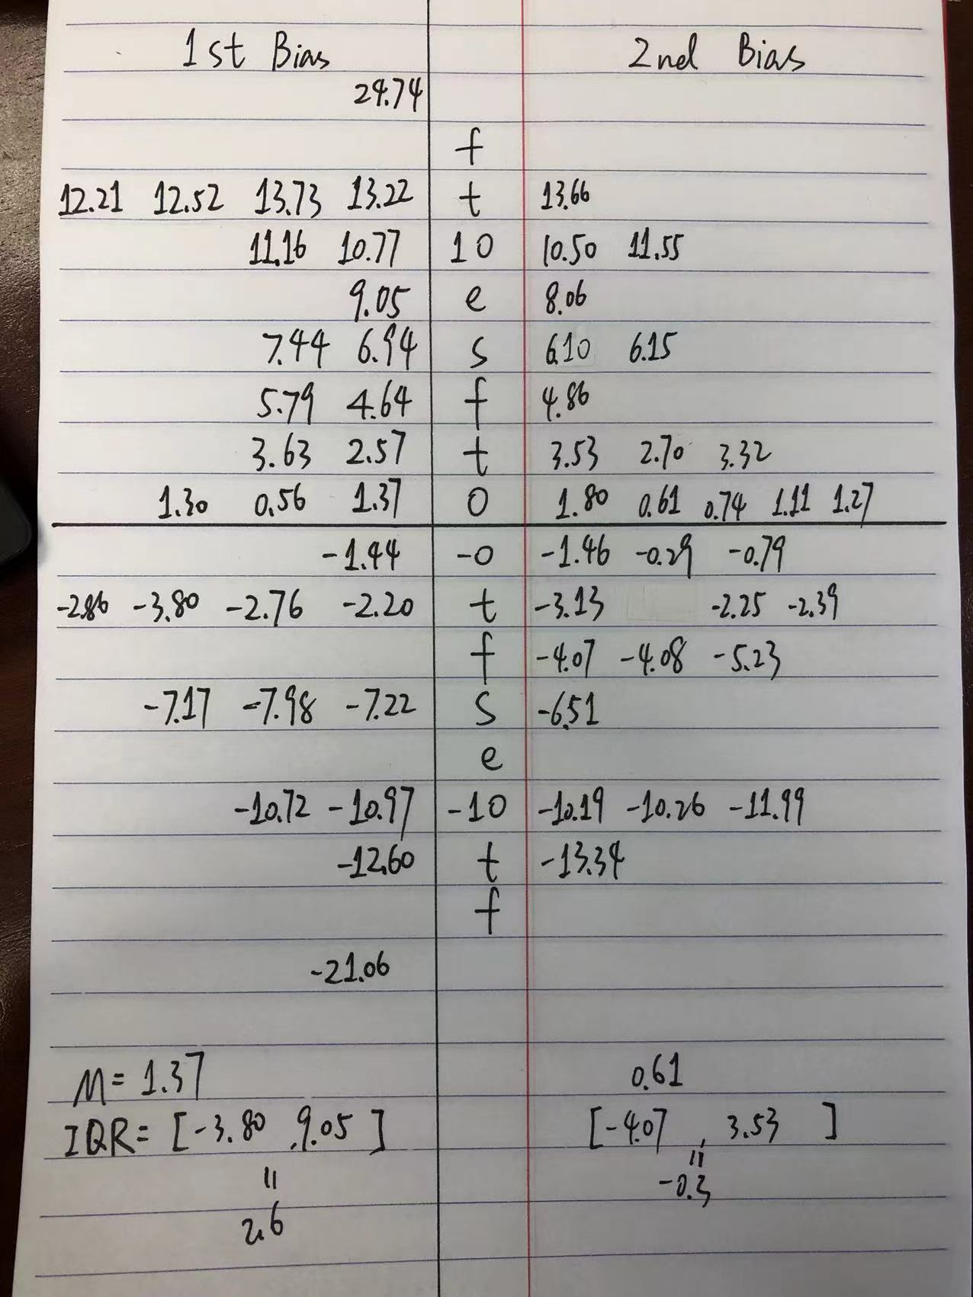

Stem-leaf-plot for SD bias after the adjustment.

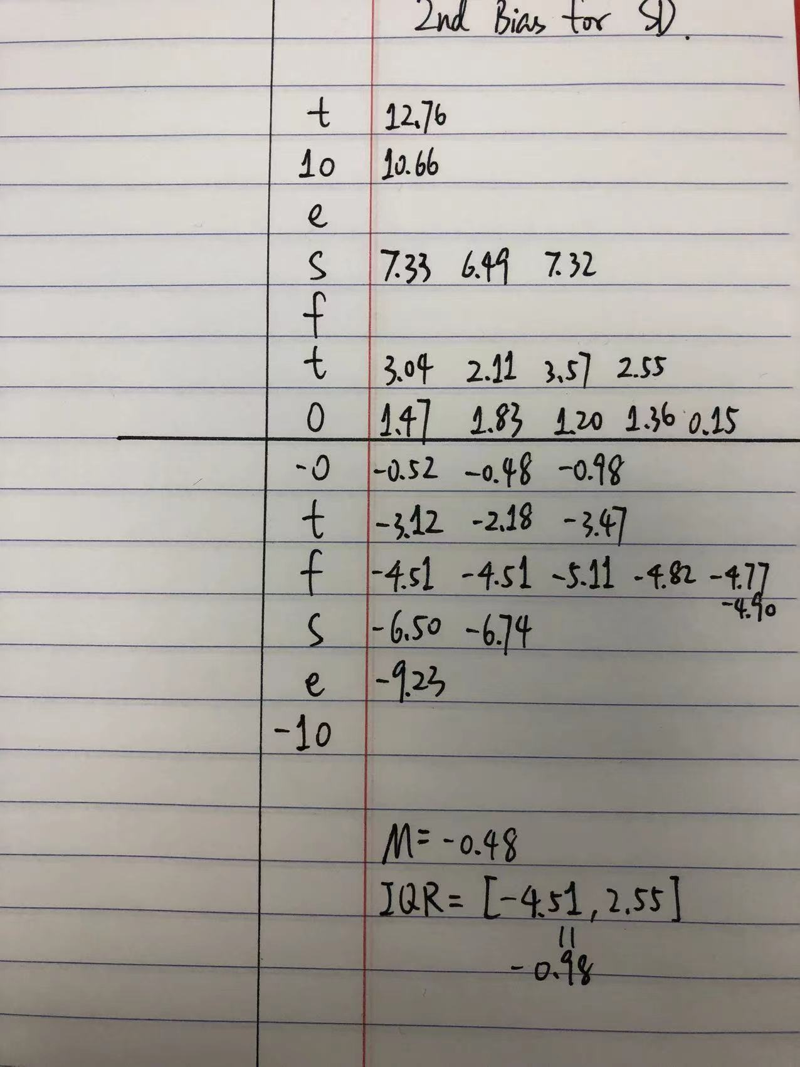

Table 16. Comparison of bias after the 2nd round adjustment between the 2011 2015 prediction and the 2015 2019 prediction (Math).

|  |  |  |  |  |
| --- | --- | --- | --- | --- |
| Country | Bias of mean  2011 to 2015 | Bias of mean  2015 to 2019 | Bias of S.D.  2011 to 2015 | Bias of S.D.  2015 to 2019 |
| Abu Dhabi | -0.95 | 1.80 | 2.22 | 1.47 |
| Australia | -6.41 | 3.53 | 0.30 | -4.51 |
| Bahrain | 0.34 | -3.13 | 1.31 | 12.76 |
| Chile | 9.69 | 10.50 | -3.71 | -0.52 |
| Dubai | 15.18 | 0.61 | -9.73 | -4.51 |
| England | -1.83 | -6.51 | -5.34 | 3.04 |
| Georgia | 3.52 | -10.19 | -6.07 | -3.12 |
| Hong Kong | -0.15 | 0.74 | 10.86 | 7.33 |
| Hungary | 5.84 | -2.25 | -14.40 | -6.50 |
| Iran | 1.25 | 13.66 | -3.79 | -2.18 |
| Ireland | -5.14 | 11.55 | -7.80 | -0.48 |
| Italy | 11.89 | 8.06 | 1.41 | 2.11 |
| Japan | -7.01 | -10.26 | 8.09 | -5.11 |
| Kazakhstan | -2.78 | -1.46 | 16.84 | 10.66 |
| Korea | 1.10 | -0.29 | 7.32 | 6.49 |
| Kuwait | 9.80 | 1.11 | 0.23 | 3.57 |
| Lithuania | -5.33 | 2.70 | -4.82 | -4.82 |
| Morocco | -0.91 | 4.86 | -3.88 | 1.83 |
| New Zealand | 10.48 | -4.07 | -1.08 | -4.77 |
| Oman | -4.28 | -2.39 | 5.42 | 7.32 |
| Ontario | 0.78 | 6.10 | -1.06 | -3.47 |
| Quebec | -2.65 | -4.08 | 0.94 | -4.90 |
| Russia | -12.31 | -5.23 | 2.47 | 1.20 |
| Singapore | 4.73 | 3.32 | 3.27 | -9.23 |
| Sweden | -10.79 | -13.34 | 2.35 | 2.55 |
| Taipei | 7.15 | -11.99 | 5.68 | -0.98 |
| Turkey | -2.97 | 6.15 | -7.17 | -6.74 |
| UAE | 2.30 | 1.27 | -1.10 | 1.36 |
| US | -2.59 | -0.79 | -2.91 | 0.15 |

Corr(Bias of mean 2011 to 2015, Bias of mean 2015 to 2019) = .218 (p = .255).

Corr(Bias of S.D. 2011 to 2015, Bias of S.D. 2015 to 2019) = .537 (p = .003).

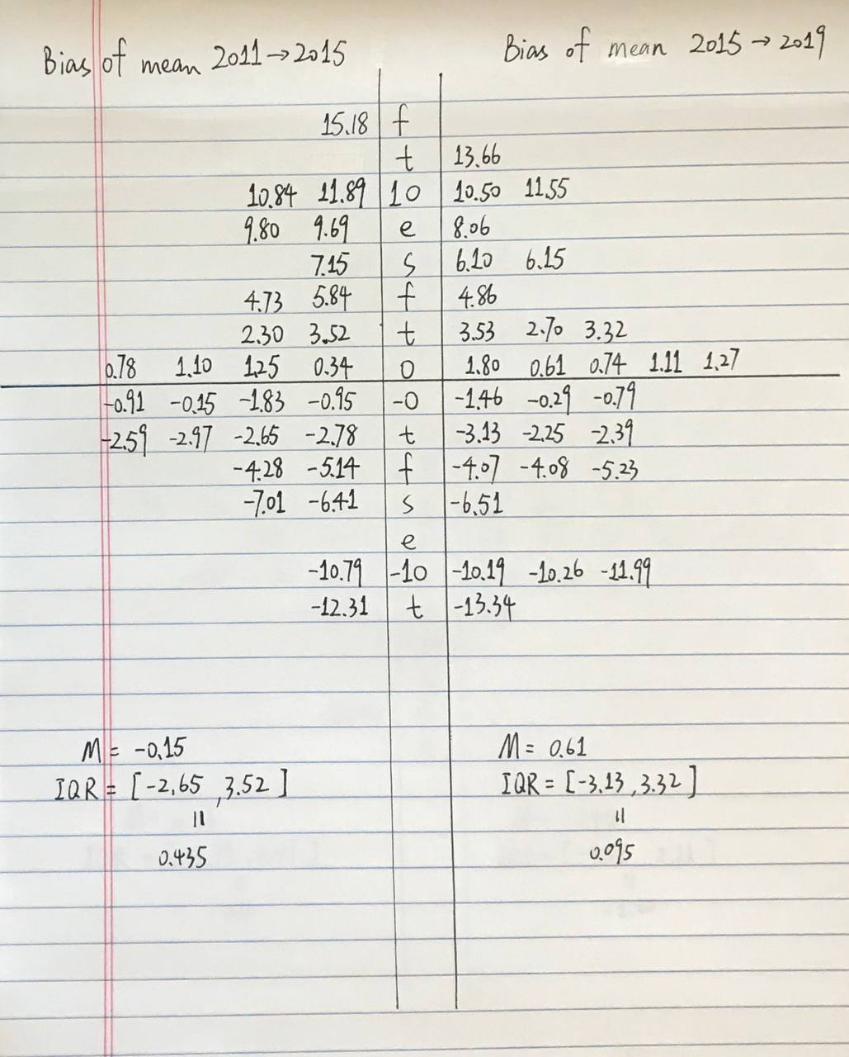Back-to-back steam-and-leaf plot for two sets of residuals for mean prediction.

Table 17. The country-level correlation of G4 actual scores and predicted scores.

|  |  |
| --- | --- |
| Country | Correlation of G4 actual scores and predicted scores |
| Abu Dhabi | 0.707 |
| Australia | 0.710 |
| Bahrain | 0.580 |
| Chile | 0.656 |
| Dubai | 0.663 |
| England | 0.651 |
| Georgia | 0.629 |
| Hong Kong | 0.646 |
| Hungary | 0.762 |
| Iran | 0.653 |
| Ireland | 0.692 |
| Italy | 0.602 |
| Japan | 0.661 |
| Kazakhstan | 0.351 |
| Korea | 0.707 |
| Kuwait | 0.518 |
| Lithuania | 0.719 |
| Morocco | 0.534 |
| New Zealand | 0.723 |
| Oman | 0.533 |
| Ontario | 0.661 |
| Quebec | 0.651 |
| Russia | 0.571 |
| Singapore | 0.737 |
| Sweden | 0.647 |
| Taipei | 0.704 |
| Turkey | 0.767 |
| UAE | 0.664 |
| US | 0.699 |

*Note:* The correlation of overall G4 actual scores and predicted scores is 0.809.

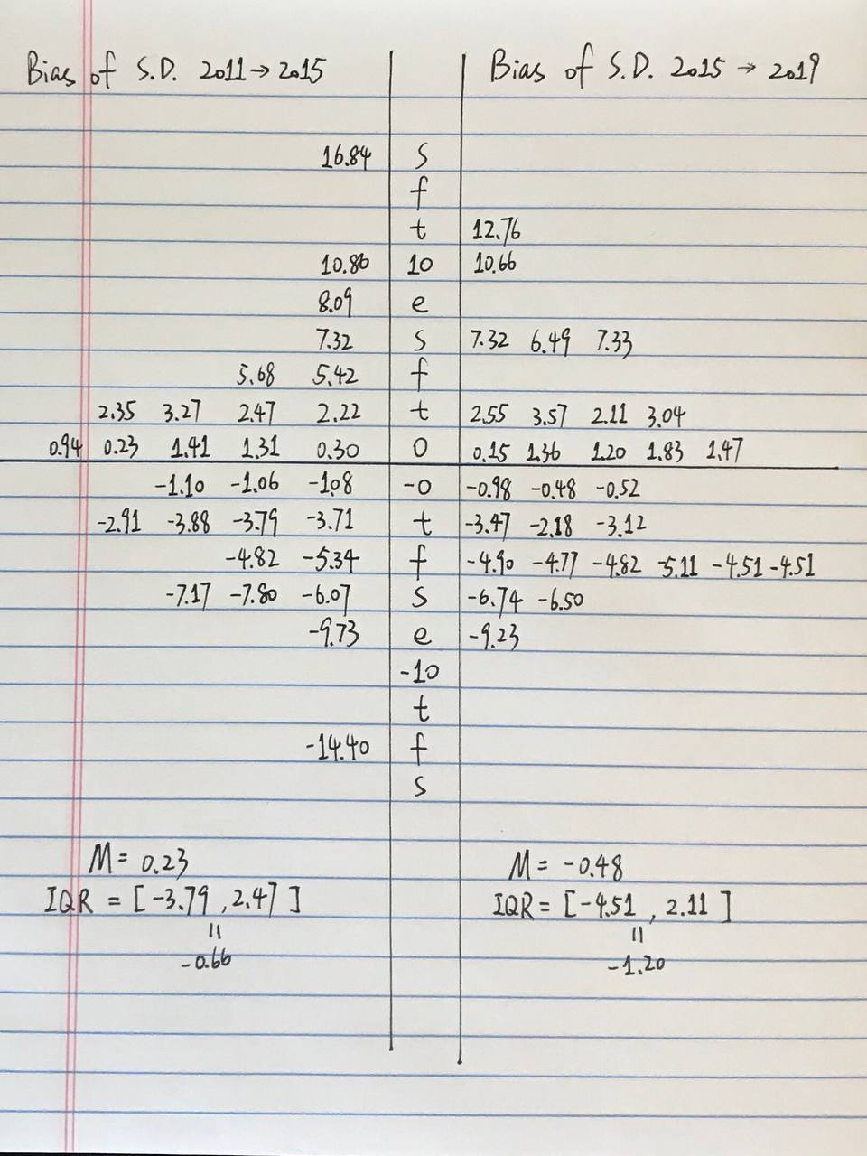Back-to-back steam-and-leaf plot for two sets of residuals for S.D. prediction.